# Music in wokwi

## Buzzer

You can use this beautiful form for buzzer:

#define BUZZER_PIN 2

void playTone(int tone, int duration) {

  for (long i = 0; i < duration * 1000L; i += tone * 2) {

    digitalWrite(BUZZER_PIN, HIGH);

    delayMicroseconds(tone);

    digitalWrite(BUZZER_PIN, LOW);

    delayMicroseconds(tone);

  }

}

void playNote(int note, int duration) {

  if (note == 0) {

    delay(duration);

  } else {

    int tone = note;

    playTone(tone, duration);

  }

}

void playMusic() {

  int melody[] = {

  1047, 1175, 1319, 1397, 1568, 1760, 1976, 2093

};

int noteDurations[] = {

  4, 8, 8, 4, 4, 4, 4, 4

};

  int repetition = 0;

  while (repetition < 3) {

    for (int i = 0; i < sizeof(melody) / sizeof(melody[0]); i++) {

      playNote(melody[i], 2000 / noteDurations[i]);

      delay(50); // Add a small delay between notes

    }

    repetition++;

    delay(1000); // Delay between repetitions

  }

}

void setup() {

  pinMode(BUZZER_PIN, OUTPUT);

  playMusic(); // Call the playMusic function

}

void loop() {

  // Code in loop will not be executed

}

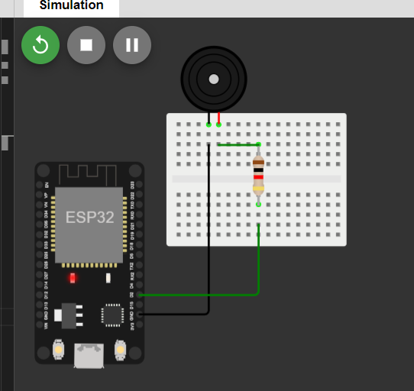

Codes for various music:

<https://github.com/AbhishekGhosh/Arduino-Buzzer-Tone-Codes>

wokwi repo:

<https://github.com/AbhishekGhosh/Arduino-Buzzer-Tone-Codes/blob/master/README.md>